Ideation Phase

Define the Problem Statements

|  |  |
| --- | --- |
| Date | 15 October 2022 |
| Team ID | PNT2022TMID03339 |
| Project Name | Emerging Methods for Early Detection of Forest Fires |
| Maximum Marks | 2 Marks |

# Customer Problem Statement:

Create a problem statement to understand your customer's point of view. The Customer Problem Statement template helps you focus on what matters to create experiences people will love.

A well-articulated customer problem statement allows you and your team to find the ideal solution for the challenges your customers face. Throughout the process, you’ll also be able to empathize with your customers, which helps you better understand how they perceive your product or service.

# Example:

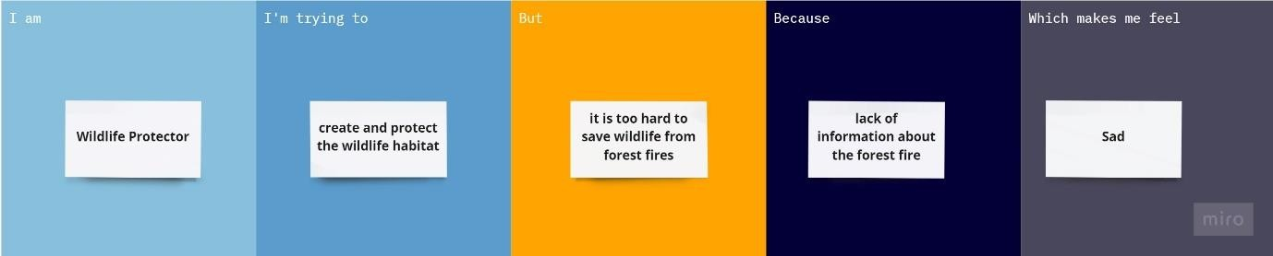

|  |  |  |  |  |  |
| --- | --- | --- | --- | --- | --- |
| **Problem Statement (PS)** | **I am** | **I’m trying to** | **But** | **Because** | **Which makes me feel** |
| **Problem Statement-1** | Aerologist | predict and analyse the composition of Earth’s atmosphere | It's a challenge to predict & analyse the damage of atmosphere by  forest fire | Lack of information about the forest fire | frustrated |
| **Problem Statement-2** | Forest ecologist | Predict & analyse the forest health | It’s too hard to predict the absolute forest fire | We can’t determine the parameter covered by  forest fire | disappointed |
| **Problem Statement-3** | Forest Ranger | Protect the forest from forest fires | It’s too hard to predict the resources required to extinguish the  forest fires | Without having a knowledge about amount of fire covered  in forest | confused |